**计算机网络大作业---制作网页**

樊恭烋荣誉学院 18021006吴天鹤

**前言：**

本次网页的制作的主题内容是Programming Language, 制作一个集合现有编程语言的网页。在制作过程中不仅学会并运用老师所讲解的html知识，同时又自学了额外一些html/CSS知识(例如在制作网页过程中用到了面向对象的思维，将属性进行封装，并运用)，配合着完成本次的大作业，老师讲解的第三章的功能也全都运用上了，title, <hr>, 表格，超链接，字体设置，颜色变换。这也是我第一次自己写前端，感受还是挺多的。由于时间有限，这次制作的内容为3个，主网页。C网页，Java网页。可以通过主网页点击C和Java字样链接到自己制作的C网页，Java网页。

**主网页html代码：**

<html>

<head>

<title>Programming Language</title>

<style type = "text/css">

.header {

background-color: black;

color:white;

text-align:center;

padding:5px;

}

.mode1 {

background-color:#666666;

color:white;

height:120px;

width:180px;

text-align:center;

float:left;

margin:7px;

padding:40px 20px 20px 20px ;

}

.mode2 {

background-color:#666666;

color:white;

height:120px;

width:180px;

text-align:center;

float:left;

margin:7px;

padding:40px 20px 20px 20px ;

}

.mode3 {

background-color:#666666;

color:white;

height:120px;

width:180px;

text-align:center;

float:right;

margin:7px;

padding:40px 20px 20px 20px ;

}

.mode4 {

background-color:#666666;

color:white;

height:120px;

width:180px;

text-align:center;

float:right;

margin:7px;

padding:40px 20px 20px 20px ;

}

.mode5 {

background-color:#666666;

color:white;

height:120px;

width:180px;

text-align:center;

float:left;

margin:7px;

padding:40px 20px 20px 20px ;

}

.mode6 {

background-color:#666666;

color:white;

height:120px;

width:180px;

text-align:center;

float:left;

margin:7px;

padding:40px 20px 20px 20px ;

}

.mode7 {

background-color:#666666;

color:white;

height:120px;

width:180px;

text-align:center;

float:right;

margin:7px;

padding:40px 20px 20px 20px ;

}

.mode8 {

background-color:#666666;

color:white;

height:120px;

width:180px;

text-align:center;

float:right;

margin:7px;

padding:40px 20px 20px 20px ;

}

.mode8 {

background-color:#666666;

color:white;

height:120px;

width:180px;

text-align:center;

float:right;

margin:7px;

padding:40px 20px 20px 20px ;

}

.mode9 {

background-color:#666666;

color:white;

height:120px;

width:180px;

text-align:center;

float:left;

margin:7px;

padding:40px 20px 20px 20px ;

}

.mode10 {

background-color:#666666;

color:white;

height:120px;

width:180px;

text-align:center;

float:left;

margin:7px;

padding:40px 20px 20px 20px ;

}

.mode11 {

background-color:#666666;

color:white;

height:120px;

width:180px;

text-align:center;

float:right;

margin:7px;

padding:40px 20px 20px 20px ;

}

.mode12 {

background-color:#666666;

color:white;

height:120px;

width:180px;

text-align:center;

float:right;

margin:7px;

padding:40px 20px 20px 20px ;

}

.table {

float:left

}

.font7 {

font-size:48px;

}

.footer {

background-color: black;

color:white;

clear:both;

text-align:center;

padding:3px;

}

a{ text-decoration:none}

</style>

</head>

<body link = white vlink = white>

<div class = "header">

<h1>Programming Language</h1>

<h5 style = "color:#FFCC00">18021006 Tianhe Wu</h5>

</div>

<div class = "mode1">

<a href = "file:///C:/Users/Tianhe%20Wu/Desktop/C.html" target = "_blank" class = "font7">C</a>

<br><br>

<font size = 3>Difficulty Level: B</font>

</div>

<div class = "mode2">

<a href = "file:///C:/Users/Tianhe%20Wu/Desktop/Java.html" target = "_blank" class = "font7">Java</a>

<br><br>

<font size = 3>Difficulty Level: A</font>

</div>

<div class = "table">

<table cellpadding = 2>

<tr><th></th><th></th><th>Dec 2019 </th><th>Dec 2018 </th><th>Programming Language</th><th>Ratings</th><th>Change</th><th>Tend</th></tr>

<tr><td></td><td></td><td align = center>1</td><td align = center>1</td><td align = center>Java</td><td align = center>17.253%</td><td align = center>+1.32%</td><td align = center>↑</td></tr>

<tr><td></td><td></td><td align = center>2</td><td align = center>2</td><td align = center>C</td><td align = center>16.086%</td><td align = center>+1.80%</td><td align = center>↑</td></tr>

<tr><td></td><td></td><td align = center>3</td><td align = center>3</td><td align = center>Python</td><td align = center>10.308%</td><td align = center>+1.93%</td><td align = center>↑</td></tr>

<tr><td></td><td></td><td align = center>4</td><td align = center>4</td><td align = center>C++</td><td align = center>6.196%</td><td align = center>-1.37%</td><td align = center>↓</td></tr>

<tr><td></td><td></td><td align = center>5</td><td align = center>6</td><td align = center>C#</td><td align = center>4.801%</td><td align = center>+1.35%</td><td align = center>↑</td></tr>

<tr><td></td><td></td><td align = center>6</td><td align = center>5</td><td align = center>Visual Basic .NET</td><td align = center>4.743%</td><td align = center>-2.38%</td><td align = center>↓</td></tr>

<tr><td></td><td></td><td align = center>7</td><td align = center>7</td><td align = center>JavaScript</td><td align = center>2.090%</td><td align = center>-0.97%</td><td align = center>↓</td></tr>

</table>

</div>

<div class = "mode3">

<font size = 7>C++</font><br><br>

<font size = 3>Difficulty Level: A+</font>

</div>

<div class = "mode4">

<font size = 7>Python</font><br><br>

<font size = 3>Difficulty Level: B-</font>

</div>

<br><br><br><br><br><br><br><br><br><br>

<div class = "mode5">

<font size = 7>C#</font><br><br>

<font size = 3>Difficulty Level: A-</font>

</div>

<div class = "mode6">

<font size = 7>SQL</font><br><br>

<font size = 3>Difficulty Level: B-</font>

</div>

<div class = "table">

<table cellpadding = 2>

<tr><th></th><th></th><th>Dec 2019 </th><th>Dec 2018 </th><th>Programming Language</th><th>Ratings</th><th>Change</th><th>Tend</th></tr>

<tr><td></td><td></td><td align = center>8</td><td align = center>8</td><td align = center>PHP</td><td align = center>2.048%</td><td align = center>-0.39%</td><td align = center>↓</td></tr>

<tr><td></td><td></td><td align = center>9</td><td align = center>9</td><td align = center>SQL</td><td align = center>1.843%</td><td align = center>-0.34%</td><td align = center>↓</td></tr>

<tr><td></td><td></td><td align = center>10</td><td align = center>14</td><td align = center>Swift</td><td align = center>1.490%</td><td align = center>+0.27%</td><td align = center>↑</td></tr>

<tr><td></td><td></td><td align = center>11</td><td align = center>17</td><td align = center>Ruby</td><td align = center>1.314%</td><td align = center>+0.21%</td><td align = center>↑</td></tr>

<tr><td></td><td></td><td align = center>12</td><td align = center>11</td><td align = center>Pascal</td><td align = center>1.280%</td><td align = center>-0.12%</td><td align = center>↓</td></tr>

<tr><td></td><td></td><td align = center>13</td><td align = center>10</td><td align = center>Objetive-C</td><td align = center>1.204%</td><td align = center>-0.27%</td><td align = center>↓</td></tr>

<tr><td></td><td></td><td align = center>14</td><td align = center>12</td><td align = center>Assembly Language</td><td align = center>1.067%</td><td align = center>-0.30%</td><td align = center>↓</td></tr>

</table>

</div>

<div class = "mode7">

<font size = 7>PHP</font><br><br>

<font size = 3>Difficulty Level: A</font>

</div>

<div class = "mode8">

<font size = 7>Go</font><br><br>

<font size = 3>Difficulty Level: B+</font>

</div>

<br><br><br><br><br><br><br><br><br><br>

<div class = "mode9">

<font size = 7>D</font><br><br>

<font size = 3>Difficulty Level: B-</font>

</div>

<div class = "mode10">

<font size = 7>JS</font><br><br>

<font size = 3>Difficulty Level: B</font>

</div>

<div class = "table">

<table cellpadding = 2>

<tr><th></th><th></th><th>Dec 2019 </th><th>Dec 2018 </th><th>Programming Language</th><th>Ratings</th><th>Change</th><th>Tend</th></tr>

<tr><td></td><td></td><td align = center>15</td><td align = center>15</td><td align = center>Go</td><td align = center>0.995%</td><td align = center>-0.19%</td><td align = center>↓</td></tr>

<tr><td></td><td></td><td align = center>16</td><td align = center>16</td><td align = center>R</td><td align = center>0.995%</td><td align = center>-0.12%</td><td align = center>↓</td></tr>

<tr><td></td><td></td><td align = center>17</td><td align = center>13</td><td align = center>MATLAB</td><td align = center>0.986%</td><td align = center>-0.30%</td><td align = center>↓</td></tr>

<tr><td></td><td></td><td align = center>18</td><td align = center>25</td><td align = center>D</td><td align = center>0.930%</td><td align = center>+0.42%</td><td align = center>↑</td></tr>

<tr><td></td><td></td><td align = center>19</td><td align = center>19</td><td align = center>Visual Basic</td><td align = center>0.929%</td><td align = center>-0.05%</td><td align = center>↓</td></tr>

<tr><td></td><td></td><td align = center>20</td><td align = center>18</td><td align = center>Perl</td><td align = center>0.889%</td><td align = center>-0.11%</td><td align = center>↓</td></tr>

</table>

</div>

<div class = "mode11">

<font size = 7>HTML</font><br><br>

<font size = 3>Difficulty Level: B-</font>

</div>

<div class = "mode12">

<font size = 7>R</font><br><br>

<font size = 3>Difficulty Level: B</font>

</div>

<br><br><br><br><br><br><br><br>

<div class = "footer">

<h5 style = "color:white">Contact email: bjut_wutianhe@qq.com</h5>

</div>

</body>

</html>

**C网页html代码:**

<html>

<head>

<title>C Programming Language</title>

<style type = "text/css">

.header {

background-color: black;

color:white;

text-align:center;

padding:5px;

}

.C1 {

background-color:#333333;

height:180px;

width:1000px;

float:left;

color:white;

margin:7px;

padding:5px ;

}

.C2 {

background-color:#333333;

height:180px;

width:1000px;

float:left;

color:white;

margin:7px;

padding:5px ;

}

.C3 {

background-color:#333333;

height:180px;

width:1000px;

float:left;

color:white;

margin:7px;

padding:5px ;

}

.imgC {

float:right;

}

.imgC2 {

float:right;

}

.imgC3 {

float:right;

}

.footer {

background-color: black;

color:white;

clear:both;

text-align:center;

padding:3px;

}

</style>

</head>

<body bgcolor = "#666666">

<div class = "header">

<h1>C Programming Language</h1>

<h5 style = "color:#FFCC00">18021006 Tianhe Wu</h5>

</div>

<font size = 15 face = Cambria color = "white">C language</font>

<font size = 12 face = Cambria color = "white">Introduction</font>

<br>

<hr size = 2 width 50% align = left noshade>

<div class = "C1">

<h2 style = "color:#FFCC00">Introduction</h2>

<p align = left style = "font-family:Cambria"><B><var style = "color:#FFFFCC">C is a general-purpose, procedural computer programming language supporting structured programming, lexical variable scope, and recursion, with a static type system. </var></B>By design, C provides constructs that map efficiently to typical machine instructions. It has found lasting use in applications previously coded in assembly language.

Such applications include operating systems and various application software for computers architectures that range from supercomputers to PLCs and embedded systems.</p>

</div>

<div class = "imgC">

<img src = "C_picture.jpg" width = "200" height = "200">

</div>

<div class = "C2">

<h2 style = "color:#FFCC00">Judge</h2>

<p align = left style = "font-family:Cambria">A successor to the programming language B, C was originally developed at Bell Labs by Dennis Ritchie between 1972 and 1973 to construct utilities running on Unix. It was applied to re-implementing the kernel of the Unix operating system. During the 1980s, C gradually gained popularity. It has become one of the most widely used programming languages, with C compilers from various vendors available for the majority of existing computer architectures and operating systems.

C has been standardized by the ANSI since 1989 (ANSI C) and by the International Organization for Standardization (ISO).</p>

</div>

<div class = "imgC2">

<img src = "C_picture2.jpg" width = "300" height = "200">

</div>

<div class = "C3">

<h2 style = "color:#FFCC00">Influence</h2>

<p align = left style = "font-family:Cambria">C is an imperative procedural language. It was designed to be compiled to provide low-level access to memory and language constructs that map efficiently to machine instructions, all with minimal runtime support. Despite its low-level capabilities, the language was designed to encourage cross-platform programming.

<var style = "color:#FFFFCC">A standards-compliant C program written with portability in mind can be compiled for a wide variety of computer platforms and operating systems with few changes to its source code.</var></p>

</div>

<div class = "imgC3">

<img src = "C_picture3.jpg" width = "400" height = "200">

</div>

<br><br><br><br><br><br><br><br>

<div class = "footer">

<h5 style = "color:white">Contact email: bjut_wutianhe@qq.com</h5>

</div>

</body>

</html>

**Java网页html代码：**

<html>

<head>

<title>Java Programming Language</title>

<style type = "text/css">

.header {

background-color: black;

color:white;

text-align:center;

padding:5px;

}

.J1 {

background-color:#999999;

height:220px;

width:900px;

float:left;

color:white;

margin:7px;

padding:5px ;

}

.J2 {

background-color:#999999;

height:483px;

width:612px;

float:left;

color:white;

margin:7px;

padding:5px ;

}

.table {

background-color:#CCCCCC;

float:left;

color:white;

margin:7px;

padding:5px ;

}

.imgJ {

float:right;

}

.imgJ2 {

float:right;

}

.imgJ3 {

float:right;

}

.footer {

background-color: black;

color:white;

clear:both;

text-align:center;

padding:3px;

}

</style>

</head>

<body bgcolor = "#666666">

<div class = "header">

<h1>Java Programming Language</h1>

<h5 style = "color:#FFCC00">18021006 Tianhe Wu</h5>

</div>

<font size = 15 face = Cambria color = "white">Java language</font>

<font size = 12 face = Cambria color = "white">Introduction</font>

<br>

<hr size = 2 width 50% align = left noshade>

<div class = "J1">

<h2 style = "color:#000000">Introduction</h2>

<p align = left style = "font-family:Cambria">Java is a general-purpose programming language that is class-based, object-oriented, and designed to have as few implementation dependencies as possible. It is intended to let application developers write once, run anywhere (WORA), meaning that compiled Java code can run on all platforms that support Java without the need for recompilation.

Java applications are typically compiled to bytecode that can run on any Java virtual machine (JVM) regardless of the underlying computer architecture. The syntax of Java is similar to C and C++, but it has fewer low-level facilities than either of them. As of 2019, Java was one of the most popular programming languages in use according to GitHub, particularly for client-server web applications, with a reported 9 million developers.</p>

</div>

<div class = "imgJ">

<img src = "Java_picture.jpg" width = "480" height = "250">

</div>

<div class = "table">

<table border = 5 cellpadding = 3>

<tr><th>Versions</th><th>Dates</th></tr>

<tr><td align = center>JDK 1.0</td><td align = center>January 23, 1996</td></tr>

<tr><td align = center>JDK 1.1</td><td align = center>February 19,1997</td></tr>

<tr><td align = center>J2SE 1.2</td><td align = center>December 9, 1998</td></tr>

<tr><td align = center>J2SE 1.3</td><td align = center>May 8,2000</td></tr>

<tr><td align = center>J2SE 1.4</td><td align = center>February 6, 2002</td></tr>

<tr><td align = center>J2SE 5.0</td><td align = center>September 30, 2004</td></tr>

<tr><td align = center>Java SE 6</td><td align = center>December 11, 2006</td></tr>

<tr><td align = center>Java SE 7</td><td align = center>July 28, 2011</td></tr>

<tr><td align = center>Java SE 8</td><td align = center>March 18, 2014</td></tr>

<tr><td align = center>Java SE 9</td><td align = center>September 21, 2017</td></tr>

<tr><td align = center>Java SE 10</td><td align = center>March 20, 2018</td></tr>

<tr><td align = center>Java SE 11</td><td align = center>September 25, 2018</td></tr>

<tr><td align = center>Java SE 12</td><td align = center>March 19, 2019</td></tr>

<tr><td align = center>Java SE 13</td><td align = center>September 17, 2019</td></tr>

<tr><td align = center>Java SE 14</td><td align = center>March 17, 2020</td></tr>

</table>

</div>

<div class = "J2">

<h2 style = "color:#000000">History</h2>

<p align = left style = "font-family:Cambria">James Gosling, Mike Sheridan, and Patrick Naughton initiated the Java language project in June 1991. Java was originally designed for interactive television, but it was too advanced for the digital cable television industry at the time. The language was initially called Oak after an oak tree that stood outside Gosling's office. Later the project went by the name Green and was finally renamed Java, from Java coffee, the coffee from Indonesia. Gosling designed Java with a C/C++-style syntax that system and application programmers would find familiar.

Sun Microsystems released the first public implementation as Java 1.0 in 1996. It promised Write Once, Run Anywhere (WORA) functionality, providing no-cost run-times on popular platforms. Fairly secure and featuring configurable security, it allowed network- and file-access restrictions. Major web browsers soon incorporated the ability to run Java applets within web pages, and Java quickly became popular. The Java 1.0 compiler was re-written in Java by Arthur van Hoff to comply strictly with the Java 1.0 language specification.

With the advent of Java 2 (released initially as J2SE 1.2 in December 1998 – 1999), new versions had multiple configurations built for different types of platforms. J2EE included technologies and APIs for enterprise applications typically run in server environments, while J2ME featured APIs optimized for mobile applications. The desktop version was renamed J2SE. In 2006, for marketing purposes, Sun renamed new J2 versions as Java EE, Java ME, and Java SE, respectively.

</p>

</div>

<div class = "imgJ2">

<img src = "Java_picture2.jpg" width = "480" height = "250">

</div>

<div class = "imgJ3">

<img src = "Java_picture3.jpg" width = "480" height = "242">

</div>

<br><br><br><br><br><br><br><br>

<div class = "footer">

<h5 style = "color:white">Contact email: bjut_wutianhe@qq.com</h5>

</div>

</body>

</html>

**主网页截图：**

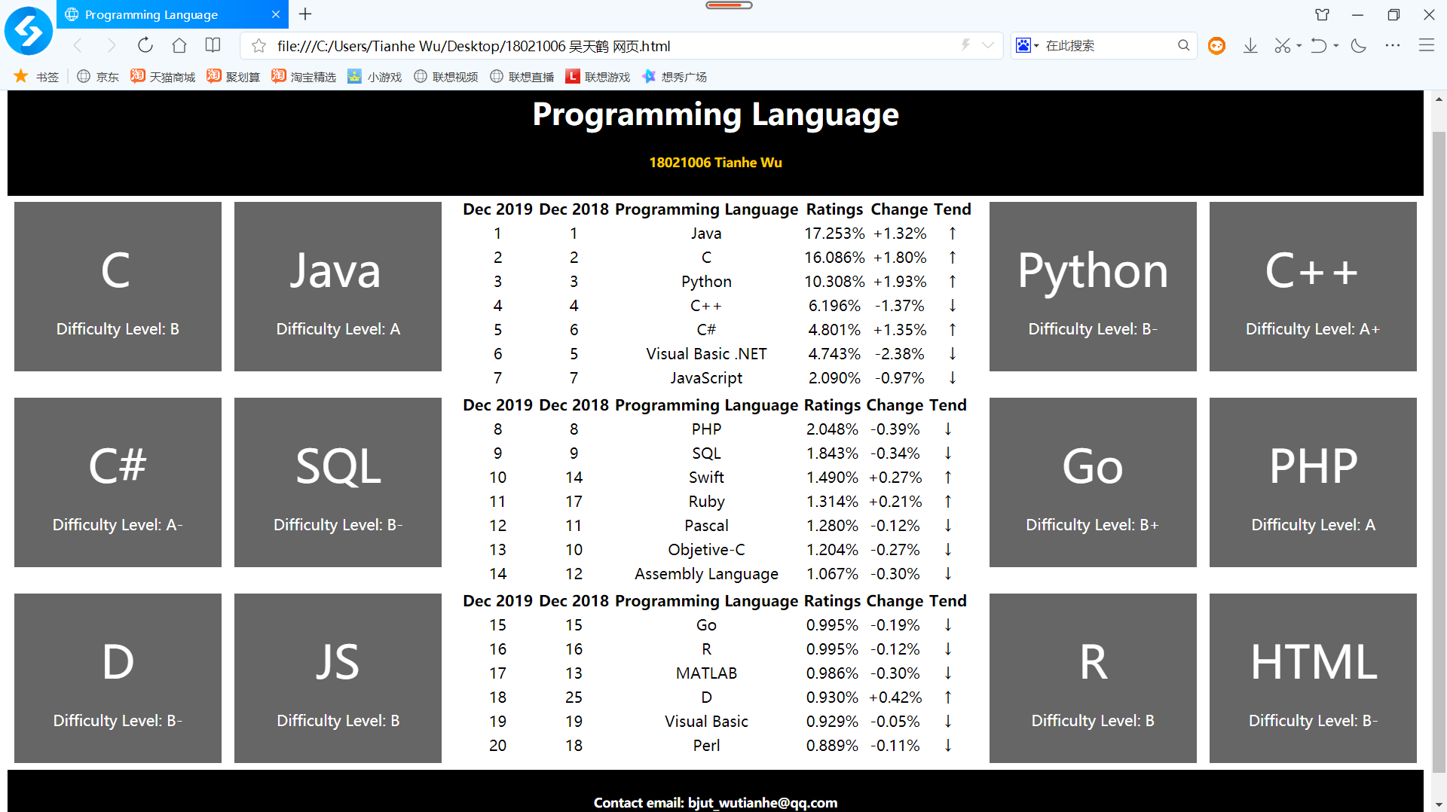

图1：主网页截图

主网页中，中间是表格，用来统计2019年世界编程语言热度排行。

两侧是各种语言及对应掌握难度。

点击C，C网页截图：

（这里我设置了取消下划线，所以C字眼下超链接的下划线就没有了）

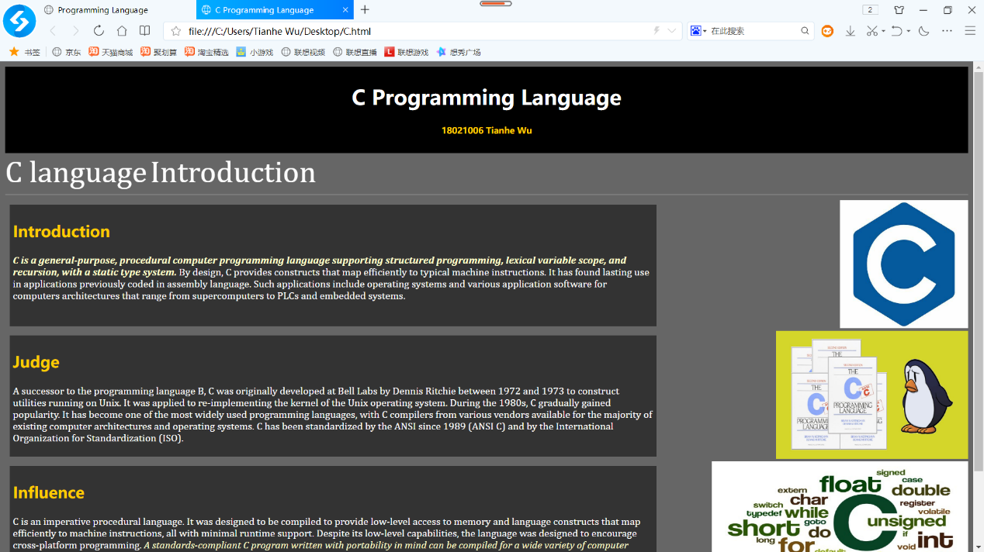

图2：C网页截图1

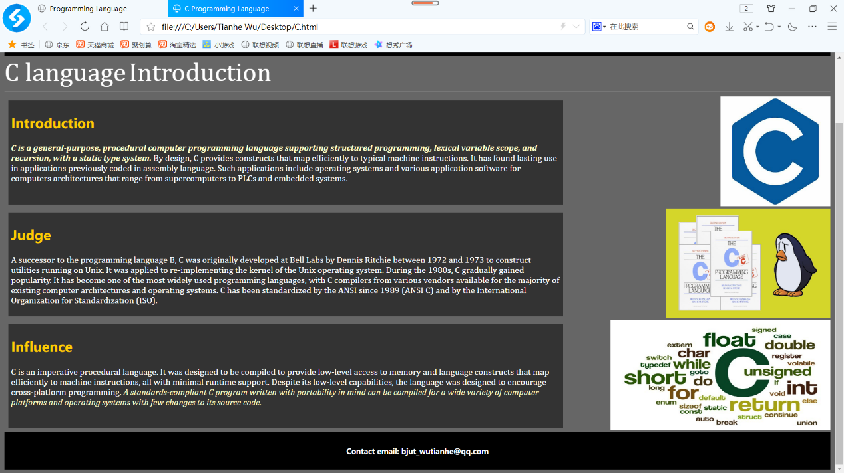

图3：C网页截图2

点击Java，Java网页截图：

（这里我设置了取消下划线，所以Java字眼下超链接的下划线就没有了）

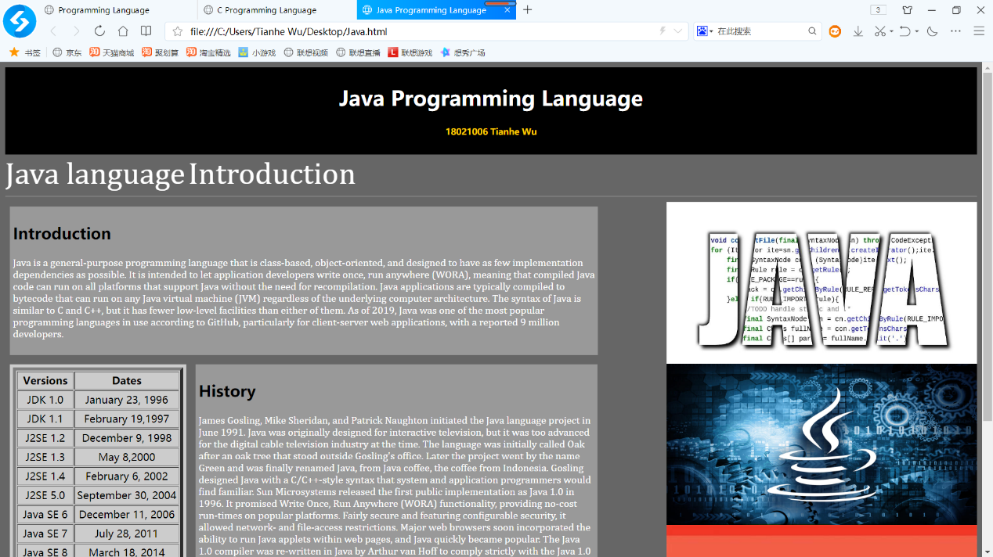

图4：Java网页截图1

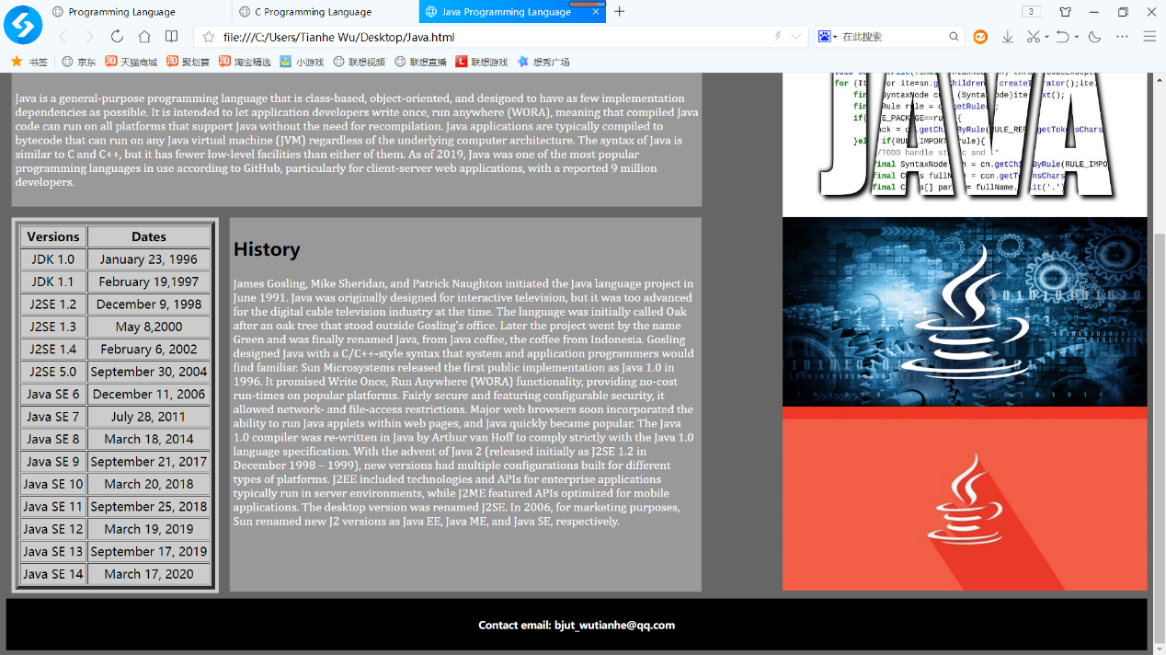

图5：Java网页截图2